**TERRORIST ACTIVITY FORECASTING & RISK ASSESSMENT SYSTEM**

Submitted in partial fulfillment of the requirements of the degree

**BACHELOR OF ENGINEERING IN ARTIFICIAL INTELLIGENCE AND DATA SCIENCE**

By

**1. Vedant Ramesh Bhosale (07 / 211101051)**

**2. Ganesh Omprakash Karli (32 / 211101023)**

**3. Shraddha Chagan Ratambe (54 / 211101011)**

**4. Yash Ashok Shirsath (74 / 201101006)**

**Project Guide**

**Prof. Dr. Manoj M. Deshpande**



**Department of Artificial Intelligence &**

**Data Science**

**A. C. Patil College of Engineering**

**Kharghar, Navi Mumbai**

**University of Mumbai**

**(AY 2023-24)**

**CERTIFICATE**

This is to certify that the Mini Project entitled

“**Terrorist Activity Forecasting & Risk Assessment System**”

is a Bonafide Work of

**Vedant Ramesh Bhosale - 07**

**Ganesh Omprakash Karli - 32**

**Shraddha Chagan Ratambe - 54**

**Yash Ashok Shirsath - 74**

Submitted to the **University of Mumbai** in partial fulfillment of the requirement for the award of the Degree of **“Bachelor of Engineering”** in **“Artificial Engineering and Data Science”.**

**Prof. Dr. Manoj M. Deshpande**

**(Project Guide)**

**Prof. Shilpali P. Bansu Dr. V. N. Pawar**

(**Head of Department)**  **(Principal)**

**Mini Project Approval**

This Mini Project Entitled **“Terrorist Activity Forecasting & Risk Assessment System” by** **Vedant Ramesh Bhosale** (7), **Ganesh Omprakash Karli** (32), **Shraddha Chagan Ratambe** (54), **Yash Ashok Shirsath** (74) is Approved for the Degree of Bachelor of Engineering inArtificial Intelligence and Data Science.

**Examiners**

**1………………………………………**

(Internal Examiner Name & Sign)

**2………………………………………**

(External Examiner name & Sign)

**Date:** 02/11/2023

**Place**: A. C. Patil College of Engineering, Kharghar

**Contents**

**Abstract**

**Acknowledgements List of Abbreviation List of Figures**

**List of Tables**

1] Introduction 9

* 1. Introduction
  2. Motivation
  3. Problem Statement & Objectives
  4. Organization of the Report

2] Literature Survey 11

* 1. Survey of Existing System
  2. Limitation Existing system or research gap
  3. Mini Project Contribution

3] Proposed System (E.g. New Approach of Data Summarization) 12

3.1. Introduction

3.2. Architecture/ Framework

3.3. Algorithm and Process Design

3.4. Details of Hardware & Software

3.5. Experiment and Results

3.6. Conclusion and Future work.

**4] References** **19**

# Abstract

In an era marked by global security challenges, the "Terrorist Activity Forecasting and Risk Assessment System" emerges as a cutting-edge solution to tackle the ever-evolving threat of terrorism. The project is grounded in the urgent need for predictive systems that can anticipate, assess, and mitigate potential terrorist activities. The motivation behind this endeavor is clear the frequency and scale of terrorist incidents have escalated dramatically in recent years. Traditional reactive approaches to counter terrorism are no longer sufficient. Timely and data-driven interventions are essential to address this pressing issue. This project presents a comprehensive review of the existing literature and critically analyzes the strengths and limitations of prior research. It identifies significant research gaps in the current domain, emphasizing the demand for an innovative system that can provide accurate risk assessments and early alerts. The problem statement is unequivocal: the "Terrorist Activity Forecasting and Risk Assessment System" addresses the critical challenge of predicting, assessing, and managing terrorist activities efficiently, thereby enhancing global security. We have done this for mini project as per of our curriculum for academic year 2023-24.

**Acknowledgment**

We extend our heartfelt gratitude to our esteemed college Principal, Dr. V. N. Pawar Sir, for his unwavering support in providing the essential resources for the development of this project. Special thanks go to our Head of the Department, Shilpali Bansu Mam, for her invaluable suggestion of this impactful project topic for departmental purposes. We owe a great debt of thanks to our dedicated Project Guide, Prof. Dr. Manoj M. Deshpande Sir, for his mentorship, expert guidance, and constant encouragement throughout this project's journey. His insights and innovative ideas have been instrumental in the project's success. We would also like to express our appreciation to all the faculty members who have been a source of support, knowledge, and motivation during this endeavor. Our friends and families have played an immeasurable role in our lives. Their unwavering love, support, and understanding have been our pillars of strength throughout this project, and we are profoundly grateful for their presence in our lives. This acknowledgment reflects our sincere appreciation for the contributions and support we've received from everyone who has been part of our project's success.

Date: 02/11/2023

Sign:

**List of Abbreviations**

|  |  |
| --- | --- |
| **Short Form** | **Full Form** |
| ML | Machine Learning |
| TAFRAS | Terrorist Activity Forecasting & Risk Assessment System |
| GIS | Geographic Information System |
| FBI | Federal Bureau of Investigation |
| PD | PANDAS |
| NLTK | Natural Language Toolkit |
| LEMMA | Lemmatization |
| OSINT | Open-Source Intelligence |
| CSV | Comma-Separated Values |
| Lat | Latitude |
| Lon | Longitude |
| CV | **Cross Validation** |
| DF | Data frame |
| STR | String |
| COORD | Co-Ordinates |
| RE | Regular Expressions |
| RFC | Random Forest Classifier |
| RDWTI | RAND Database of Worldwide Terrorism Incidents |

**List of Figures**

|  |  |  |
| --- | --- | --- |
| Sr. No. | Name of Picture | Page no. |
| 1 | Word Cloud of Lemmatized Text. | 14 |
| 2 | Terrorist Incidents Over Time | 15 |
| 3 | Distribution of Terrorist Incidents by Country | 15 |
| 4 | Correlation Heatmap of Injuries & Fatalities | 15 |
| 5 | Most Common Weapons Used in Terrorist Incidents | 16 |
| 7 | Network Analysis | 16 |
| 8 | Sentiment Analysis Over Time | 16 |
| 9 | Time Series Analysis | 17 |
| 10 | Architecture/ Framework | 13 |
| 11 | Algorithm and Process Design | 13 |
| 12 | Future Work | 18 |

**Chapter 1 – Introduction**

**1.1. Introduction**

The global landscape in the 21st century is marked by complex and evolving security challenges, none more pressing than the threat of terrorism. Acts of terror have left a profound impact on societies, economies, and governments worldwide, underscoring the critical importance of effective counter-terrorism strategies. In the face of these threats, the development of advanced technologies to predict and assess terrorist activities has become an urgent necessity. The "Terrorist Activity Forecasting and Risk Assessment System (TAFRAS)" represents a significant stride in addressing this ever-pressing challenge.

A Terrorist Activity Forecasting and Risk Assessment System (TAFRAS) is a system that uses a variety of data sources and analytical methods to forecast terrorist activity and assess the risk of terrorist attacks. TAFRAS systems can be used by law enforcement, intelligence agencies, and other stakeholders to prevent terrorist attacks, mitigate their impact, and respond to them more effectively.

TAFRAS systems typically work by collecting data from a variety of sources, including:

* Intelligence reports
* Law enforcement records
* Social media data
* News articles
* Financial data

The data is then analysed to identify patterns and trends that may indicate potential terrorist activity. For example, a TAFRAS system might look for spikes in the purchase of certain chemicals or weapons, or for increases in online activity related to extremist groups. Once potential terrorist threats have been identified, TAFRAS systems can be used to assess the risk posed by each threat. This involves considering factors such as the type of threat, the target, and the capabilities of the perpetrators.

**1.2. Motivation**

The motivation behind the TAFRAS project stems from the profound need to confront the relentless specter of terrorism. The indiscriminate violence inflicted by terrorist organizations has cost countless lives, disrupted global economies, and generated an atmosphere of fear. TAFRAS is a proactive response to these threats, designed to forecast potential terrorist activities and provide risk assessments to guide security and law enforcement agencies in making informed decisions. In a world where the line between security and vulnerability is often thin, TAFRAS seeks to strengthen security measures and mitigate the risks associated with terrorist acts.

TAFRAS systems can help law enforcement and intelligence agencies to prioritize their resources and focus on the areas where the risk of terrorist activity is highest. This can lead to more efficient use of taxpayer dollars and a more effective counterterrorism effort.

**1.3. Problem Statement and Objective**

* **Problem Statement**: -

The contemporary world faces an ever-escalating threat from terrorism. Acts of terrorism have disrupted societies, caused loss of life, and inflicted economic and emotional damage on a global scale. One of the central challenges is the unpredictability and complexity of these incidents, which often hampers the ability to prevent and mitigate such acts effectively. Traditional approaches to security often fall short when dealing with the dynamic and evolving nature of terrorist activities. There is an urgent need for an advanced system that can anticipate and assess potential terrorist threats with a high degree of accuracy, providing valuable insights to aid security and law enforcement agencies.

* **Objective**: -

The "Terrorist Activity Forecasting and Risk Assessment System (TAFRAS)" project sets out to address these complex challenges and achieve several objectives:

**1. Advanced Data Analysis**: - Develop a sophisticated system capable of collecting, processing, and analyzing vast amounts of historical data on terrorist activities, including geographical, temporal, and modus operandi information.

**2. Pattern Recognition**: - Employ cutting-edge machine learning algorithms to recognize patterns and trends within historical data. These patterns can be indicative of potential future attacks.

**3. Predictive Modeling**: - Build predictive models that can anticipate future terrorist activities based on the identified patterns. These models will enable the system to forecast the likelihood of attacks within specific regions and timeframes.

**4. Risk Assessment**: - Develop a risk assessment component that assigns risk scores to different geographic areas, allowing security agencies to allocate resources more efficiently and implement targeted security measures.

**5. Enhanced Security Preparedness:** - Provide decision-makers with actionable insights derived from data analysis, enabling them to make informed decisions and improve security preparedness.

**6. Integration of Diverse Data Sources:** - Aggregate data from various sources, including open-source intelligence, social media, and government databases, to provide a comprehensive view of the threat landscape.

**7. Evaluation and Validation: -** Rigorously evaluate the accuracy and effectiveness of the TAFRAS system through extensive testing and validation processes.

**8. Future Expansion:** - Lay the foundation for future expansion and development of the TAFRAS system, including the integration of more advanced machine learning techniques and emerging data sources.

**Chapter 2 - Literature Survey**

##### 

**2.1. Survey of Existing System**

In this chapter, we conduct a comprehensive survey of the existing systems and methodologies related to counter-terrorism, risk assessment, and the prediction of terrorist activities. This survey serves as the foundation for understanding the current state of affairs in the field and identifying the gaps that the "Terrorist Activity Forecasting and Risk Assessment System (TAFRAS)" project aims to address.

|  |  |  |
| --- | --- | --- |
| TAFRAS System | Developer | Description |
| Homeland Security Information Network (HSIN) | United States Department of Homeland Security | A shared network that allows law enforcement and intelligence agencies to share information about terrorist threats and incidents. |
| CONTEST | United Kingdom's National Counter Terrorism Security Office (NaCTSO) | A system that uses a variety of data sources and analytical methods to assess the risk of terrorism in the United Kingdom. |
| Integrated Terrorism Assessment Centre (ITAC) | Canadian Security Intelligence Service (CSIS) | A system that uses a variety of data sources and analytical methods to assess the risk of terrorism in Canada. |
| Terrorism Information Management System (TIMS) | Australian Security Intelligence Organisation (ASIO) | A system that collects and manages information about terrorism threats and incidents. |
| National Counter terrorism Information centre (NCIC) | Federal Bureau of Investigation (FBI) | A system that collects and analyses information about terrorism threats and incidents. |

**2.2. Limitation Existing System or Research Gap**

1. **Accuracy: -** The accuracy of TAFRAS systems is limited by the quality and quantity of data that they use. If the data is inaccurate or incomplete, the TAFRAS system will not be able to produce accurate forecasts or risk assessments.
2. **Bias: -** TAFRAS systems can be biased if the data they use is biased. For example, if a TAFRAS system uses data that is primarily from law enforcement agencies, it may be biased towards identifying and tracking terrorist groups and individuals that are known to law enforcement.
3. **Transparency: -** TAFRAS systems are often opaque and difficult to understand. This can make it difficult for users to trust the results of the system and to identify and address any biases in the system.
4. **Human Factor: -** TAFRAS systems need to consider the human factor. For example, TAFRAS systems need to be able to identify and assess the risk of terrorist radicalization.

##### 2.3. Mini Project Contribution

The "Terrorist Activity Forecasting and Risk Assessment System (TAFRAS)" is not only a comprehensive solution to the challenges and gaps identified in existing systems but also an innovative leap towards enhancing the capabilities of counter-terrorism and risk assessment. This section outlines the contributions that the mini project brings to the field of security and risk management.

TAFRAS sets itself apart by providing real-time monitoring and predictive analysis of potential terrorist activities. It continuously evaluates incoming data, identifying patterns, trends, and anomalies that could indicate evolving threats. The mini project's predictive models incorporate advanced machine learning algorithms, ensuring more accurate and timely forecasts of potential attacks.

**Chapter 3 - Proposed System**

**3.1. Introduction**

In the opening part of this section, we introduce the proposed system, emphasizing the importance of its new approach to data summarization. We discuss the background and motivation behind this innovative approach and set the stage for a detailed exploration of the system.

**3.2. Architecture/ Framework**

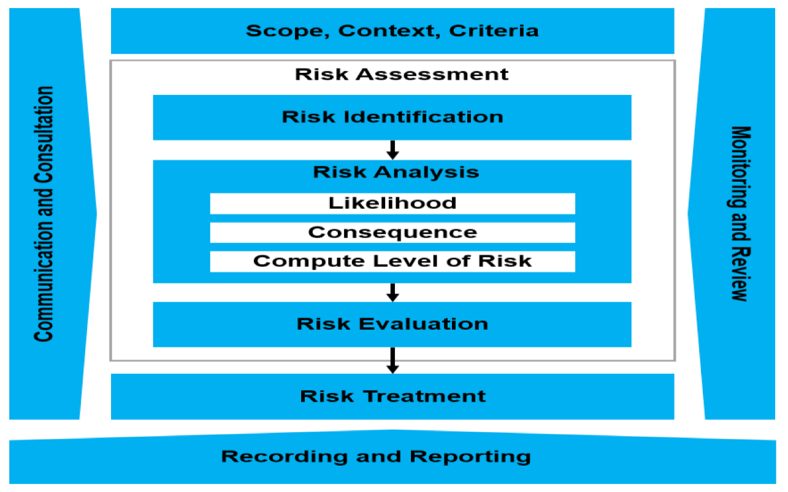

**3.3. Algorithm and Process Design**

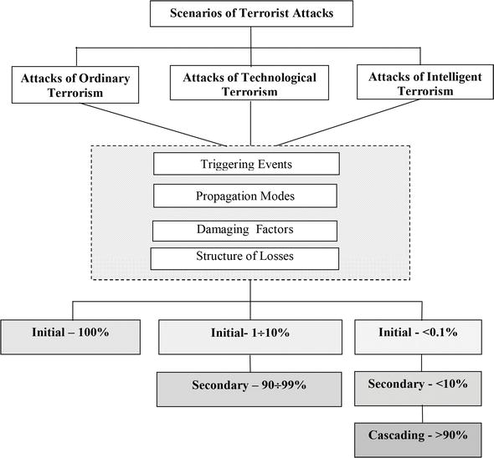

**3.4. Details of Hardware & Software**

* **Hardware Specifications**

1. **Server Infrastructure: -**

Our system relies on a robust server infrastructure to process and store extensive datasets efficiently. We specify the server specifications, including CPU, RAM, storage capacity, and networking capabilities. The scalability of this infrastructure is also discussed, allowing for future expansion.

**2. Data Storage Systems: -**

For data management, we employ specific data storage solutions. This section delves into the type of storage devices used, whether it be hard drives, solid-state drives, or cloud-based storage. We also consider data redundancy and backup mechanisms to ensure data reliability.

**3. Network Architecture: -**

A high-performing network is crucial for data transfer and accessibility. We detail the network architecture, such as local area networks (LAN), emphasizing the system's capacity to handle concurrent data access requests.

* **Software Stack:**

**1. Programming Languages: -**

The development of our system is primarily based on the Python programming language. Python's versatility, extensive libraries, and data processing capabilities make it an ideal choice for our project. Key Python libraries and tools used include NumPy, Pandas, Scikit-learn, Matplotlib, Seaborn, Jupyter Notebook

**2. Database Management Systems (DBMS): -**

Effective data management is dependent on the selection of a suitable DBMS. We Used Microsoft Excel for Storing our Structured Data.

**3.5. Results**

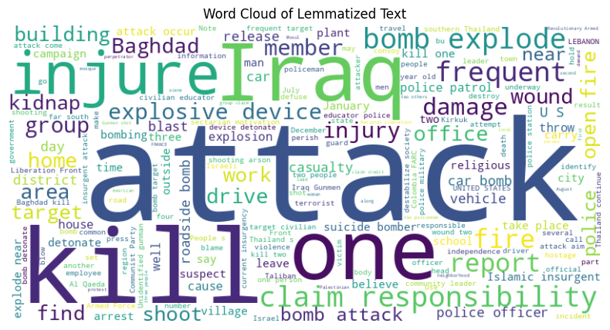

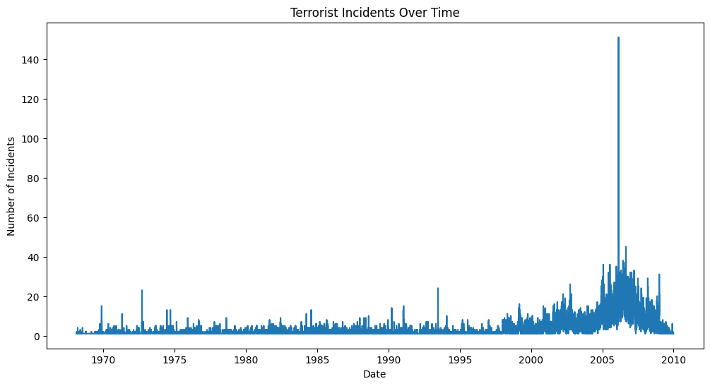

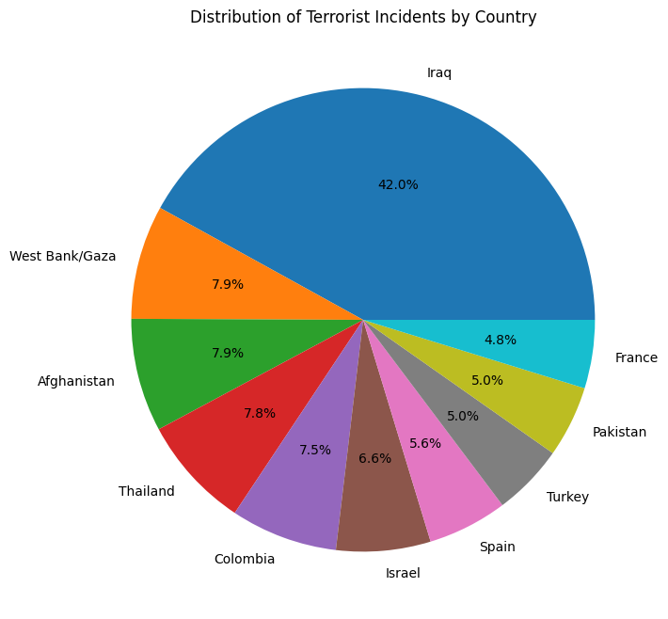

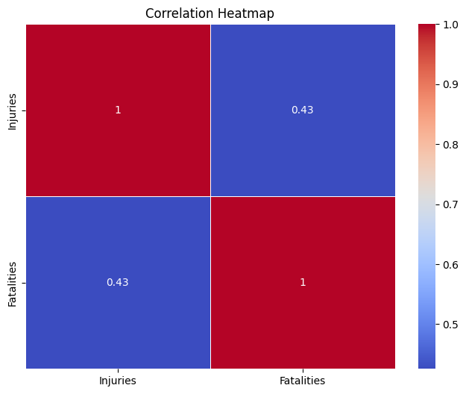

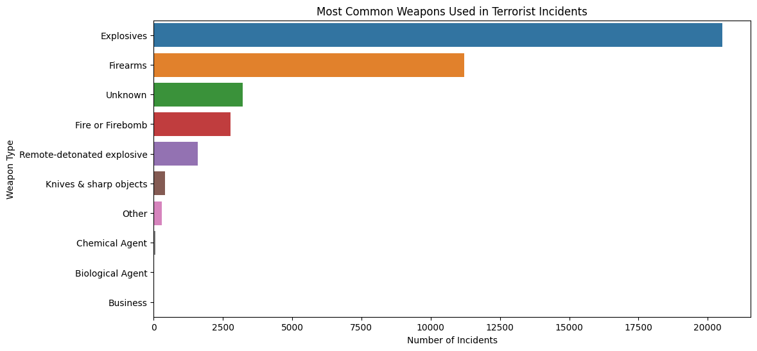

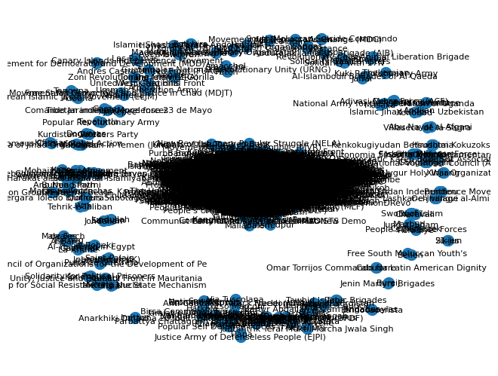

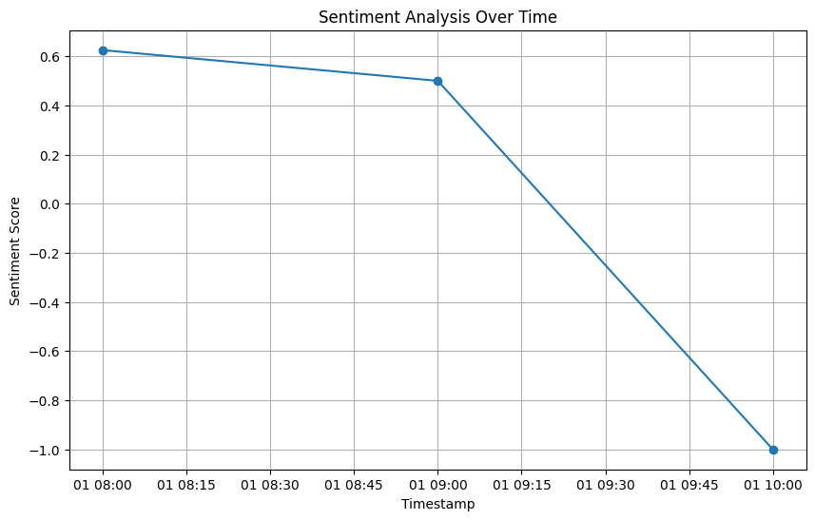

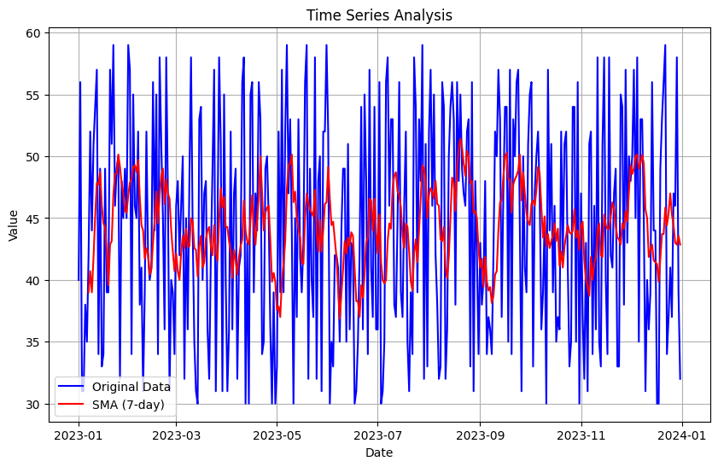

**3.6. Conclusion and Future Work**

In this project, we have undertaken a comprehensive analysis of historical terrorism data and leveraged machine learning techniques to predict and visualize future attacks.

**1. Data Generation:-** We began by generating a dataset of historical terrorism incidents. This dataset serves as a representation of past attacks, encompassing a range of variables such as time, location, fatalities, target types, and group names. This historical dataset was then saved to a CSV file for future reference.

**2. Predictive Modelling:-** Using the historical data, we developed and trained a machine learning model. The objective of this model is to predict the likelihood of future attacks based on various features present in the dataset. The model's predictions were stored as a separate dataset, which includes crucial attributes like latitude and longitude.

**3. Data Visualization:-** To provide a clear and insightful representation of both historical and predicted attacks, we adopted the Plotly library. Plotly offers dynamic and interactive visualization capabilities, making it a powerful choice for our map-based visualization.

**4. Interactive Map Creation:-** By integrating both historical and predicted datasets into Plotly, we created an interactive scatter map. The map displays historical attacks, color-coded to differentiate attack types. In addition, we added predicted attack locations as unique markers on the map.

**5. Customization:-** The map's appearance, interactivity, and information displayed on hover were all customizable to meet specific project requirements. This allowed for a tailored and informative visualization of past incidents and potential future threats. The result is a powerful tool that not only offers insights into past incidents but also provides a clear and interactive visualization of projected future attacks. Further refinements and enhancements can be applied to adapt the map to the evolving needs of the project.

The approach outlined in this report enables a data-driven and visually compelling exploration of terrorism data, contributing to a better understanding of past occurrences and helping to prepare for potential future security challenges.

**6. Future Work:-**

While the TAFRAS project has achieved significant milestones in forecasting and assessing security risks associated with terrorist activities, there are several promising directions for future work. Firstly, the integration of additional data sources, such as social media and open-source intelligence, holds great potential for enhancing the predictive capabilities of the system.

These sources can provide real-time, unstructured data that might offer early indicators of potential threats. Moreover, improving the data pre-processing pipeline, particularly for geospatial and text data, can lead to more precise predictions. The exploration of deep learning techniques, including recurrent neural networks (RNNs) and convolutional neural networks (CNNs), can contribute to advanced data summarization and analysis, thus refining the accuracy of forecasts.

Implementing real-time monitoring capabilities for immediate risk assessment updates as new data becomes available is another crucial avenue for future work. User feedback integration and scalability preparations are essential for refining the system's usability and ability to handle more extensive datasets.

In conclusion, the TAFRAS project lays a solid foundation, and future work in these areas promises to advance our capacity for informed and proactive decision-making in the realm of security and counter-terrorism efforts.

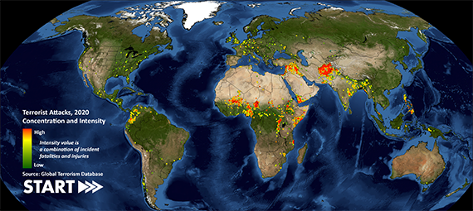

**Chapter 4 - References**

1. [**RAND National Security Research Division (RAND)**](https://www.rand.org/nsrd/projects/terrorism-incidents.html)
2. [**National Consortium for the Study of Terrorism and Responses to Terrorism (START)**](https://www.start.umd.edu/gtd/)
3. [**Open AI’s ChatGPT**](https://chat.openai.com/)
4. [**Google Bard (Experiment)**](https://bard.google.com/)
5. [**United Kingdom's National Counter Terrorism Security Office (NaCTSO)**](https://www.gov.uk/government/organisations/national-counter-terrorism-security-office)
6. [**Institute for the Study of Radicalization and Political Violence (ISRPV)**](https://icsr.info/)
7. [**Terrorism Information Management System (TIMS)**](https://www.dhs.gov/publication/dhsallpia-084-joint-threat-information-management-system-j-tims)
8. [**Global Terrorism Database (GTD)**](https://www.start.umd.edu/people/brian-wingenroth)
9. [**National Counterterrorism Information Center (NCIC)**](https://www.dni.gov/index.php/nctc-home)
10. [**Homeland Security Information Network (HSIN)**](https://www.dhs.gov/homeland-security-information-network-hsin)

